Title of Thesis or Dissertation Title Case (150 characters or less with spaces)
________________________
A thesis
presented to
the faculty of the Department of Chemistry
East Tennessee State University

In partial fulfillment
of the requirements for the degree
Master of Science in Chemistry
______________________
by
Your Name
Graduation Month Year
_____________________
Committee Chair name, Chair
Committee Member
Committee Member

Keywords: keywords, lower case, lower case

plain language abstract
All manuscripts are now required to have a plain language abstract in addition to the regular abstract. A plain language abstract for a thesis is strictly limited to 150 words or less, 350 words or less for a dissertation.

A plain language abstract is a short, simple explanation of your research. It should not use jargon or technical terms. It should be understandable by an average member of the public. It should simply explain why the research was done, how it was done, and the key findings. The purpose is to make your research more accessible to more people. This is especially important for reaching a broader audience, including policymakers, journalists, and the public.

For additional help, go to the first link under the Writing Help tab on the Resources page.

ABSTRACT
Title of Thesis or Dissertation Exactly How it Appears on the Title Page
by
Your Name
Do not indent the first line. Master’s abstracts are strictly limited to 150 words or less, Dissertations are limited to 350 words or less. Keep line spacing consistent with the rest of your thesis (if using double spacing, use throughout). Double spacing has been used in this template.

Separate multiple paragraphs with an extra line space.

Copyright 2019 by Your Name
All Rights Reserved

Generative Artificial Intelligence Disclosure
Only include this page if needed. Fill in the information below fully and accurately. Otherwise delete this page along with the heading.

Generative Artificial Intelligence (GAI) tools, including [specific tools], were utilized in this [capstone project/thesis/dissertation/synthesis project] for [specific uses]. While AI-generated outputs were reviewed for accuracy, relevance, and integrity to align with academic standards, I am responsible for the integrity, originality, and academic validity of this scholarly work.

dedication
This page is optional. The copyright page is optional also. Use indented paragraph format.

acknowledgements
This page is optional. Use indented paragraph format.

TABLE OF CONTENTS
plain language abstract 2
ABSTRACT 3
Generative Artificial Intelligence Disclosure 5
dedication 6
acknowledgements 7
List of tables 9
LIST OF FIGURES 10
List of abbreviations 11
Chapter 1. introduction 12
First Level Subheading Goes Here 12
Second Level Subheading Goes Here 12
CHAPTER 2. title of chapter 14
Subheading Goes Here 14
Chapter 3. title of chapter 15
Subheading Goes Here 15
Chapter 4. title of chapter 16
references 17
appendices 18
Appendix A: Title of Appendix 18
VITA 19
NOTE: You will be creating your own Table of Contents, this one is just an example that contains the headings in this template. Your table of contents (TOC) will only contain your headings if you link each heading to the correct style. The styles have been created in this template, but you must assign each new heading to the style. Also NOTE: A linked TOC like this is not required, but preferred. Help

List of tables
Table 1. Table Titles are in Title Case 10
Table 2. If the Table Title is More than Two Lines then Move to the Next Line but Do Not
Let the Text Spill Past the Table Number or Page Number 12

- ONLY include a list of tables or figures if you have more than one entry.
- Use tabs to move the 2nd and subsequent lines so the text doesn’t overlap with the table/figure numbers or page numbers.
- NOTE: You may create your lists manually. It is not required to have them linked, and linking table and figure captions will only work for some students due to the limited capabilities of that option. If you’d like to try to link them here is some help:
How to insert captions
How to create a table of figures

LIST OF FIGURES
Figure 1. Organic chemistry. Figure captions are in sentence style. 11
Figure 2. Organic chemistry. Figure captions are in sentence style. 11

List of abbreviations
Abbreviation Description
Abbreviation Description
Abbreviation Description

Chapter 1. introduction

First Level Subheading Goes Here
Begin your text here, be sure your initial sentence of each new paragraph is indented ½ inch.

Second Level Subheading Goes Here
Text begins here.
Third level subheading. This level is indented, begins the paragraph, and is followed by a period. Third level subheadings are in sentence style.
Equations must be typed and labeled as (chapter.number) For example:
The rate is given by equation (1.1): $-\frac{d(CH_{3}CO)_{2}O}{dt}=k[\left(CH_{3}CO)_{2}O\right]\left[H_{2}O\right]$ (1.1)
Table 1. Table Titles are in Title Case and Above the Table
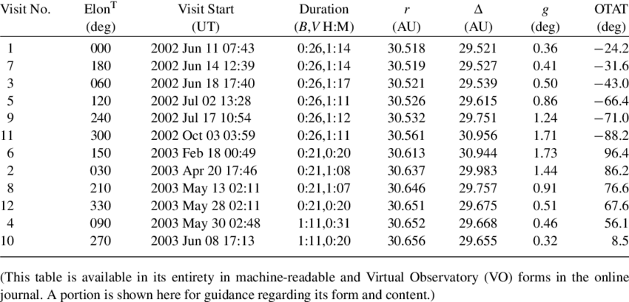
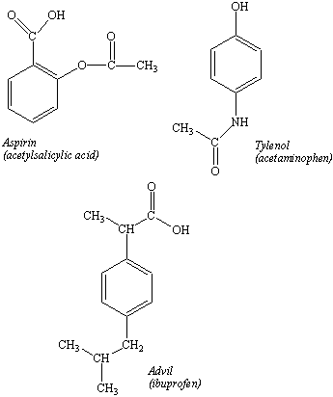
Figure 1. Figure captions are in sentence style. They can be centered or flush left under the figure.

CHAPTER 2. title of chapter

Subheading Goes Here

Chapter 3. title of chapter

Subheading Goes Here

Chapter 4. title of chapter

references

appendices

Appendix A: Title of Appendix

If only one appendix:
APPENDIX: Title of Appendix

VITA
YOUR NAME
Education: M.S. Chemistry, East Tennessee State University, Johnson
City, Tennessee, 2019
B.A. Economics, East Tennessee State University, Johnson
City, Tennessee, 2015
Public Schools, Erwin, Tennessee
Professional Experience: Teacher, Gatlinburg-Pitman High School; Gatlinburg, Tennessee, 2005-2019
Graduate Assistant, East Tennessee State University, College of
Arts and Sciences, 2017-2019
Publications: Smith, John J. (2010). "What Everyone Should Know."
Universal Magazine. New York: Omnibus Press.
pp.8-15.
Honors and Awards: Who's Who in American Colleges
Outstanding Thesis Award, East Tennessee State University, 2016

